DELHI TECHNOLOGICAL UNIVERSITY (Formerly Delhi College of Engineering) Shahbad Daulatpur, Bawana Road, Delhi 110042)

DEPARTMENT OF COMPUTER SCIENCE



MACHINE LEARNING (CS303)
LAB FILE

SUBMITTED TO - SUBMITTED BY -
Dr.Ashish Kumar Pranjwal Jha Department of Computer Science 23/MC/107

INDEX
S.No | EXPERIMENT | DATE | SIGN
1 | To build and test a K-Nearest Neighbors (KNN) machine learning classifier.
2 | To perform data ingestion and cleaning on the Titanic dataset.
3 | To implement an end-to-end data preprocessing pipeline using scikit-learn
4 | To build an end-to-end regression pipeline.
5 | To train, evaluate, and compare a range of classification models, including Logistic Regression, Decision Tree, Random Forest, AdaBoost, and KNN, on the Telco Churn dataset
6 | To robustly evaluate and optimize classification models using a comprehensive set of metrics, stratified cross-validation, and hyperparameter tuning techniques.
7 | To apply Principal Component Analysis (PCA) for dimensionality reduction and data visualization on the Iris dataset, and to interpret the resulting principal components and feature loadings.
8 | To implement, tune, and compare advanced ensemble models (AdaBoost and XGBoost) for a binary classification problem using the Adult Income dataset, with a focus on comprehensive evaluation using metrics like F1-Score and ROC AUC, and feature importance analysis.
9 | Build an Artificial Neural Network (ANN) by implementing the Backpropagation algorithm from scratch or using deep learning libraries (TensorFlow/Keras)
10 | To partition a given dataset into 'K' distinct, non-overlapping clusters using K-Means clustering

INPUT:
import numpy as np
import pandas as pd
import matplotlib.pyplot as plt
import seaborn as sns
from sklearn.datasets import load_iris
from sklearn.model_selection import train_test_split, cross_val_score
from sklearn.neighbors import KNeighborsClassifier
from sklearn.metrics import accuracy_score, confusion_matrix, classification_report

sns.set()

iris = load_iris()
X = pd.DataFrame(iris.data, columns=iris.feature_names)
y = pd.Series(iris.target, name="target")

print("Shape:", X.shape)
display(X.head())

sns.pairplot(pd.concat([X, y], axis=1), hue="target");
plt.suptitle("Iris pairplot", y=1.02)

X_train, X_test, y_train, y_test = train_test_split(X, y, test_size=0.30,random_state=42, stratify=y)

results = []
for k in [1, 3, 5, 7, 9]:
knn = KNeighborsClassifier(n_neighbors=k)
knn.fit(X_train, y_train)
preds = knn.predict(X_test)
acc = accuracy_score(y_test, preds)
cv = cross_val_score(knn, X, y, cv=5).mean()
results.append((k, acc, cv))
print(f"k={k} | test_acc={acc:.4f} | cv5_mean={cv:.4f}")

res_df = pd.DataFrame(results, columns=["k", "test_acc", "cv5_mean"])
display(res_df)

best_k = int(res_df.sort_values("test_acc", ascending=False).iloc[0]["k"])
best_model = KNeighborsClassifier(n_neighbors=best_k).fit(X_train, y_train)
preds = best_model.predict(X_test)
print("Confusion matrix:\n", confusion_matrix(y_test, preds))
print("\nClassification report:\n", classification_report(y_test, preds))

OUTPUT:
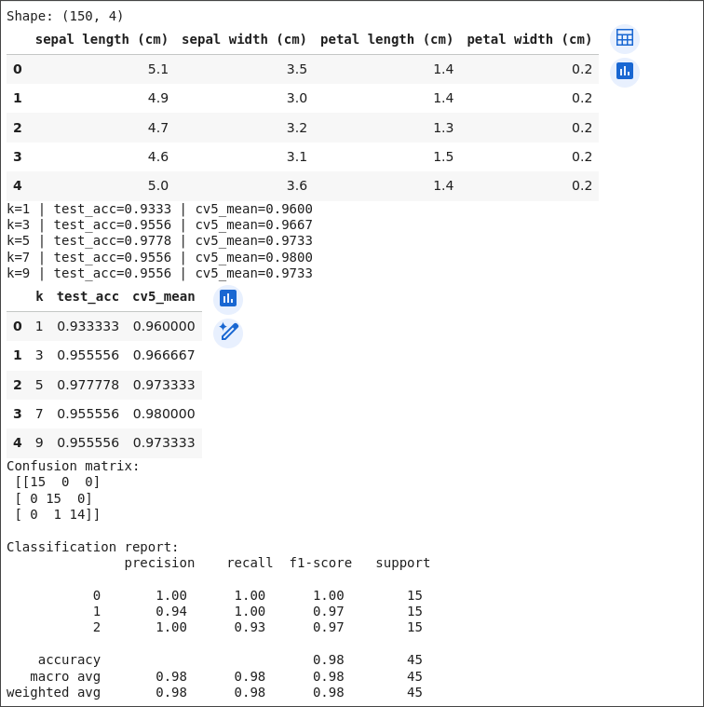
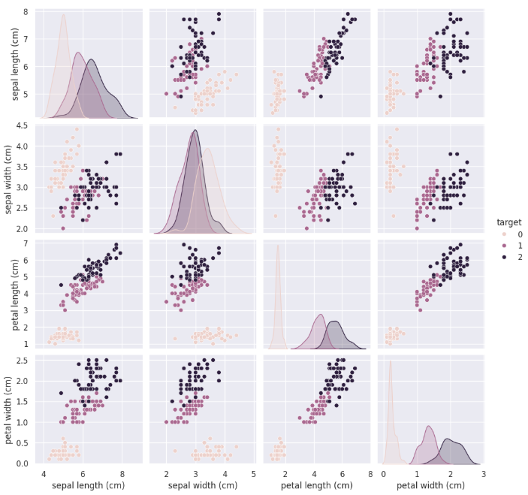

LEARNING OUTCOMES:
- Load and explore the Iris dataset
- Visualize features using pairplots
- Train and test a KNN classifier
- Connect distance-based learning to vector space
- Relate classification results to class probabilities

INPUT:
import numpy as np
import pandas as pd
import matplotlib.pyplot as plt
import seaborn as sns
from scipy import stats

sns.set()

try:
df = sns.load_dataset("titanic")
print("Loaded seaborn Titanic dataset")
except Exception as e:
print("seaborn dataset not available, please provide CSV path")
df = pd.DataFrame()

display(df.head())
print(df.info())
display(df.describe(include="all"))

plt.figure(figsize=(8,4))
sns.heatmap(df.isna(), cbar=False)
plt.title("Missing values heatmap")
plt.show()

def simple_impute(df):
df = df.copy()
if "age" in df.columns:
df["age_was_missing"] = df["age"].isna().astype(int)
df["age"] = df["age"].fillna(df["age"].median())
if "embarked" in df.columns:
df["embarked"] = df["embarked"].fillna(df["embarked"].mode().iloc[0])
if "fare" in df.columns:
df["fare"] = df["fare"].fillna(df["fare"].median())
return df

df_clean = simple_impute(df)
display(df_clean.head())

def iqr_clip(df, col):
df = df.copy()
if col in df.columns:
Q1 = df[col].quantile(0.25)
Q3 = df[col].quantile(0.75)
IQR = Q3 - Q1
lower, upper = Q1 - 1.5 * IQR, Q3 + 1.5 * IQR
df[col + "_outlier"] = ((df[col] < lower) | (df[col] > upper)).astype(int)
df[col] = df[col].clip(lower, upper)
return df

if "fare" in df_clean.columns:
df_clean = iqr_clip(df_clean, "fare")
print("Fare outlier flag count:\n", df_clean["fare_outlier"].value_counts())

OUTPUT:
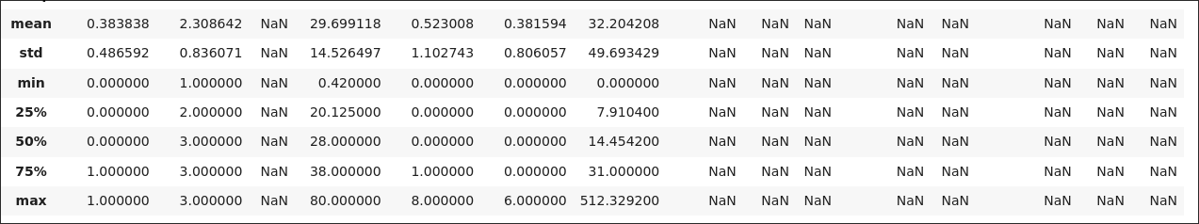
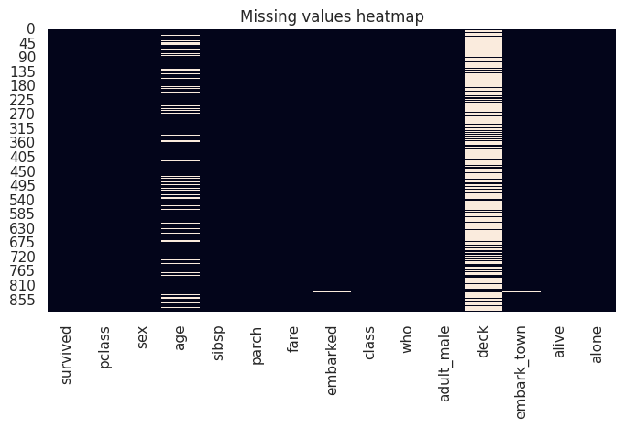
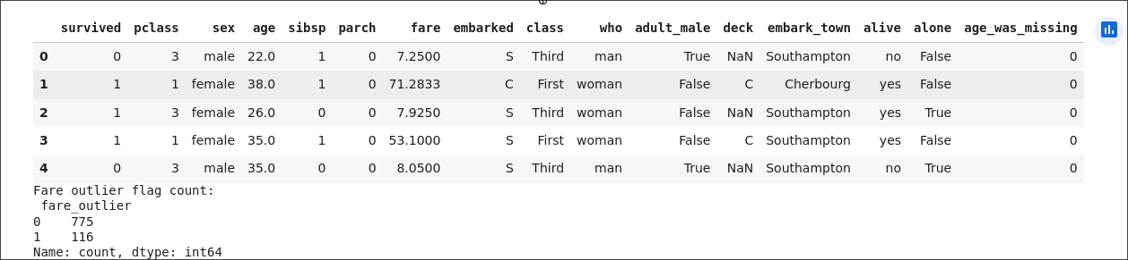

LEARNING OUTCOMES:
Apply a reproducible data ingestion and cleaning process.
Handle missing and outlier values in Titanic dataset.
Document preprocessing choices for reproducibility.

INPUT:
iimport numpy as np
import pandas as pd
from sklearn.pipeline import Pipeline
from sklearn.compose import ColumnTransformer
from sklearn.preprocessing import OneHotEncoder, StandardScaler
from sklearn.model_selection import train_test_split
import joblib
import seaborn as sns
sns.set()
df = pd.DataFrame({
"num1": np.random.randn(200),
"num2": np.random.rand(200)*10,
"cat1": np.random.choice(["A","B","C"], 200),
"target": np.random.choice([0,1], 200, p=[0.6,0.4])
})
numeric_cols = ["num1", "num2"]
categorical_cols = ["cat1"]
target_col = "target"
X = df[numeric_cols + categorical_cols]
y = df[target_col]
preprocessor = ColumnTransformer(transformers=[
("num", StandardScaler(), numeric_cols),
("cat", OneHotEncoder(handle_unknown="ignore", sparse_output=False), categorical_cols)
])
pipeline = Pipeline(steps=[
("preproc", preprocessor)
])
X_train, X_test, y_train, y_test = train_test_split(X, y, test_size=0.2, stratify=y, random_state=42)
pipeline.fit(X_train)
X_train_t = pipeline.transform(X_train)
X_test_t = pipeline.transform(X_test)
print("Transformed shapes:", X_train_t.shape, X_test_t.shape)
joblib.dump(pipeline, "preprocessing_pipeline.joblib")
print("Saved preprocessing_pipeline.joblib")

OUTPUT:
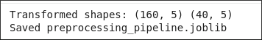
LEARNING OUTCOMES:
Implement an end-to-end preprocessing pipeline in sklearn.
Perform feature engineering & selection.
Save train/test splits and preprocessing artifacts.

INPUT:
import numpy as np
import pandas as pd
import matplotlib.pyplot as plt
from sklearn.model_selection import train_test_split
from sklearn.linear_model import LinearRegression
from sklearn.preprocessing import PolynomialFeatures
from sklearn.metrics import mean_squared_error, r2_score
np.random.seed(42)
X = pd.DataFrame({
"x1": np.linspace(0,10,200),
"x2": np.random.randn(200)*2
})
y = 3.5 * X["x1"] - 1.2 * X["x2"] + 4 + np.random.randn(200)*3
def manual_linear_fit(x, y):
x = np.asarray(x).ravel()
y = np.asarray(y).ravel()
x_mean = x.mean()
y_mean = y.mean()
num = ((x - x_mean) * (y - y_mean)).sum()
den = ((x - x_mean) ** 2).sum()
w = num / den
b = y_mean - w * x_mean
return w, b

w, b = manual_linear_fit(X["x1"], y)
print("Manual OLS (x1): w =", w, "b =", b)

y_pred_manual = w * X["x1"] + b
print("Manual OLS MSE:", mean_squared_error(y, y_pred_manual), "R2:", r2_score(y, y_pred_manual))

X_train, X_test, y_train, y_test = train_test_split(X, y, test_size=0.2, random_state=42)
lr = LinearRegression().fit(X_train, y_train)
y_pred_lr = lr.predict(X_test)
print("LinearRegression MSE:", mean_squared_error(y_test, y_pred_lr), "R2:", r2_score(y_test, y_pred_lr))

poly = PolynomialFeatures(degree=2, include_bias=False)
X_poly = poly.fit_transform(X[["x1"]])
Xtr_p, Xte_p, ytr_p, yte_p = train_test_split(X_poly, y, test_size=0.2, random_state=42)
lr_poly = LinearRegression().fit(Xtr_p, ytr_p)
y_pred_poly = lr_poly.predict(Xte_p)
print("Poly deg2 MSE:", mean_squared_error(yte_p, y_pred_poly), "R2:", r2_score(yte_p, y_pred_poly))

plt.figure(figsize=(6,4))
plt.scatter(y_test, y_pred_lr, alpha=0.7)
plt.plot([y_test.min(), y_test.max()], [y_test.min(), y_test.max()], "--")
plt.xlabel("True")
plt.ylabel("Predicted")
plt.title("True vs Predicted (Linear Regression)")
plt.show()

OUTPUT:
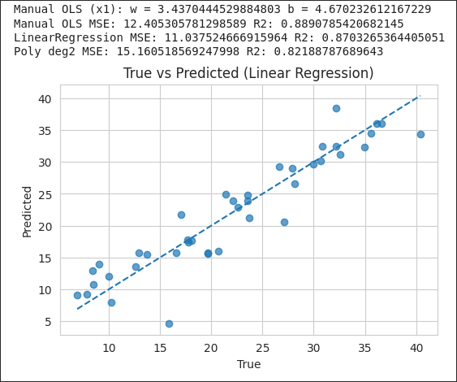

LEARNING OUTCOMES:
1. Preprocess numerical features for regression.
2. Train and evaluate linear, multiple, and polynomial regression models.
3. Compare manual vs library-based implementations.

INPUT:
import numpy as np
import pandas as pd
import matplotlib.pyplot as plt
import seaborn as sns
from sklearn.model_selection import train_test_split
from sklearn.preprocessing import StandardScaler, OneHotEncoder
from sklearn.compose import ColumnTransformer
from sklearn.pipeline import Pipeline
from sklearn.linear_model import LogisticRegression
from sklearn.tree import DecisionTreeClassifier
from sklearn.ensemble import RandomForestClassifier, AdaBoostClassifier
from sklearn.neighbors import KNeighborsClassifier
from sklearn.metrics import accuracy_score, roc_auc_score, roc_curve, confusion_matrix, classification_report
import joblib

sns.set()

np.random.seed(0)
df = pd.DataFrame({
"tenure": np.random.randint(1, 72, 500),
"monthly_charges": np.random.uniform(20, 120, 500),
"contract": np.random.choice(["Month-to-month","One year","Two year"], 500),
"internet_service": np.random.choice(["DSL","Fiber optic","No"], 500),
"gender": np.random.choice(["Male","Female"], 500),
"churn": np.random.choice([0,1], 500, p=[0.73,0.27])
})

target = "churn"
cat_cols = ["contract", "internet_service", "gender"]
num_cols = ["tenure", "monthly_charges"]

X = df[num_cols + cat_cols]
y = df[target]
preproc = ColumnTransformer(transformers=[
("num", StandardScaler(), num_cols),
("cat", OneHotEncoder(handle_unknown="ignore", sparse_output=False), cat_cols)
])

models = {
"LogisticRegression": LogisticRegression(max_iter=500),
"DecisionTree": DecisionTreeClassifier(random_state=42),
"RandomForest": RandomForestClassifier(n_estimators=100, random_state=42),
"AdaBoost": AdaBoostClassifier(n_estimators=50, random_state=42),
"KNN": KNeighborsClassifier(n_neighbors=5)
}

X_train, X_test, y_train, y_test = train_test_split(X, y, stratify=y, test_size=0.2, random_state=42)
results = []
fpr_tpr = {}
for name, clf in models.items():
pipe = Pipeline(steps=[("preproc", preproc), ("clf", clf)])
pipe.fit(X_train, y_train)
preds = pipe.predict(X_test)
acc = accuracy_score(y_test, preds)
probs = None
try:
probs = pipe.predict_proba(X_test)[:, 1]
auc = roc_auc_score(y_test, probs)
except Exception:
auc = None
print(f"{name} -> acc: {acc:.4f} | auc: {auc}")
results.append((name, acc, auc))
if probs is not None:
fpr, tpr, _ = roc_curve(y_test, probs)
fpr_tpr[name] = (fpr, tpr)

res_df = pd.DataFrame(results, columns=["model", "accuracy", "auc"]).sort_values("accuracy", ascending=False)
display(res_df)
plt.figure(figsize=(7,6))
for name, (fpr, tpr) in fpr_tpr.items():
plt.plot(fpr, tpr, label=name)
plt.plot([0,1],[0,1],"--", color="gray")
plt.xlabel("FPR")
plt.ylabel("TPR")
plt.title("ROC Curves")
plt.legend()
plt.show()
best_name = res_df.iloc[0]["model"]
best_clf = models[best_name]
best_pipeline = Pipeline(steps=[("preproc", preproc), ("clf", best_clf)])
best_pipeline.fit(X, y) # fit on full data
joblib.dump(best_pipeline, f"best_model_{best_name}.joblib")
print(f"Saved best model pipeline as best_model_{best_name}.joblib")

OUTPUT:
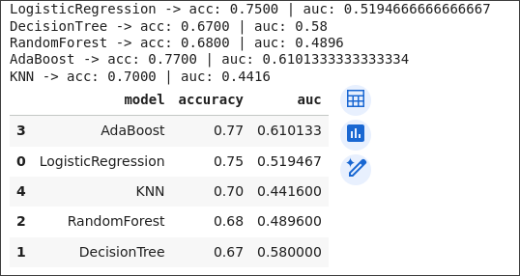
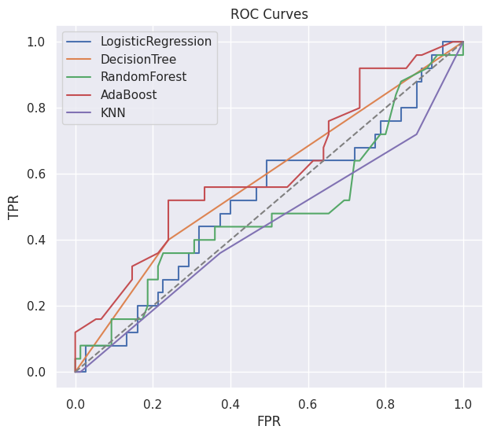

LEARNING OUTCOMES:
1. Train and evaluate a range of classification models: Logistic Regression, Decision Tree, Random Forest, AdaBoost, and KNN.
2. Use accuracy, ROC AUC, and confusion matrices for model evaluation.
3. Interpret trade-offs between different classifiers and justify a deployment choice.
4. Save results and best-performing models for reproducibility.

INPUT:
import time
import numpy as np
import pandas as pd
import matplotlib.pyplot as plt
import seaborn as sns
from sklearn.model_selection import train_test_split, StratifiedKFold, GridSearchCV, RandomizedSearchCV
from sklearn.preprocessing import StandardScaler
from sklearn.linear_model import LogisticRegression
from sklearn.ensemble import RandomForestClassifier
from sklearn.metrics import classification_report, roc_auc_score, roc_curve, RocCurveDisplay
import warnings
import scipy.stats as st

warnings.filterwarnings("ignore")
sns.set_style("whitegrid")
np.random.seed(42)

def create_data(n_samples=7000):
data = pd.DataFrame({
"tenure": np.random.randint(0, 72, n_samples),
"MonthlyCharges": np.random.uniform(20, 120, n_samples),
"TotalCharges": np.random.uniform(20, 8000, n_samples),
"Contract": np.random.choice(["Month-to-month", "One year", "Two year"], n_samples),
"InternetService": np.random.choice(["DSL", "Fiber optic", "No"], n_samples),
"Churn": np.random.choice([0, 1], n_samples, p=[0.73, 0.27])
})
return data

def preprocess(data):
data_encoded = pd.get_dummies(data, columns=["Contract", "InternetService"], drop_first=True)
X = data_encoded.drop("Churn", axis=1)
y = data_encoded["Churn"]

numerical_cols = ["tenure", "MonthlyCharges", "TotalCharges"]
scaler = StandardScaler()
X[numerical_cols] = scaler.fit_transform(X[numerical_cols])

return X, y, scaler

def train_and_tune(X_train, y_train, cv_strategy):
results = {}

print("\n=== Logistic Regression GridSearch ===")
lr = LogisticRegression(random_state=42, max_iter=2000, solver="saga", tol=1e-4)
lr_params = {"C": [0.01, 0.1, 1, 10, 100], "penalty": ["l1", "l2"]}

lr_gs = GridSearchCV(
lr,
lr_params,
cv=cv_strategy,
scoring="f1",
n_jobs=1,
verbose=2
)
t0 = time.time()
lr_gs.fit(X_train, y_train)
t1 = time.time()
print(f"LR GridSearch done in {t1-t0:.1f}s")
results["lr_best_estimator"] = lr_gs.best_estimator_
results["lr_gs"] = lr_gs

print("\n=== RandomForest RandomizedSearch ===")
rf = RandomForestClassifier(random_state=42)
param_dist = {
"n_estimators": st.randint(50, 300),
"max_depth": st.randint(3, 30),
"min_samples_split": st.randint(2, 10),
"min_samples_leaf": st.randint(1, 8),
"bootstrap": [True, False]
}
rf_rand = RandomizedSearchCV(
rf,
param_distributions=param_dist,
n_iter=30,
cv=cv_strategy,
scoring="f1",
n_jobs=-1,
verbose=2,
random_state=42
)
t0 = time.time()
rf_rand.fit(X_train, y_train)
t1 = time.time()
print(f"RF RandomizedSearch done in {t1-t0:.1f}s")
results["rf_best_estimator"] = rf_rand.best_estimator_
results["rf_rand"] = rf_rand

return results

def evaluate(estimator, X_test, y_test, model_name="model"):
print(f"\n--- Evaluation: {model_name} ---")
y_pred = estimator.predict(X_test)
if hasattr(estimator, "predict_proba"):
y_proba = estimator.predict_proba(X_test)[:, 1]
elif hasattr(estimator, "decision_function"):
y_proba = estimator.decision_function(X_test)
else:
y_proba = None

print(classification_report(y_test, y_pred, digits=4))
if y_proba is not None:
auc = roc_auc_score(y_test, y_proba)
print(f"ROC AUC: {auc:.4f}")

fpr, tpr, _ = roc_curve(y_test, y_proba)
plt.figure(figsize=(6, 5))
plt.plot(fpr, tpr, lw=2)
plt.plot([0, 1], [0, 1], "--", lw=1)
plt.xlabel("False Positive Rate")
plt.ylabel("True Positive Rate")
plt.title(f"ROC Curve - {model_name} (AUC={auc:.3f})")
plt.tight_layout()
plt.show()
else:
print("No probability or decision_function available; skipping ROC/AUC.")

if __name__ == "__main__":
data = create_data(n_samples=7000)
X, y, scaler = preprocess(data)
X_train, X_test, y_train, y_test = train_test_split(
X, y, test_size=0.2, random_state=42, stratify=y
)
print(f"Data prepared. Training set size: {len(X_train)}, Test set size: {len(X_test)}")

cv_strategy = StratifiedKFold(n_splits=5, shuffle=True, random_state=42)

results = train_and_tune(X_train, y_train, cv_strategy)

evaluate(results["lr_best_estimator"], X_test, y_test, model_name="LogisticRegression (best)")
evaluate(results["rf_best_estimator"], X_test, y_test, model_name="RandomForest (best)")
print("\nSummary of best CV scores:")
print("LR best CV f1:", results["lr_gs"].best_score_)
print("RF best CV f1:", results["rf_rand"].best_score_)

OUTPUT:
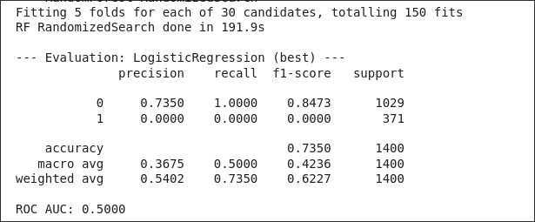
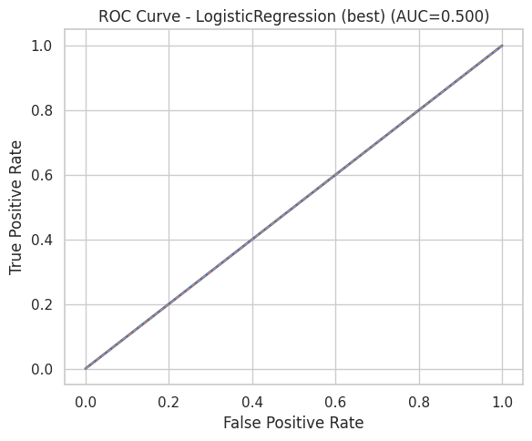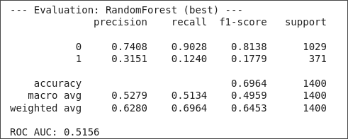
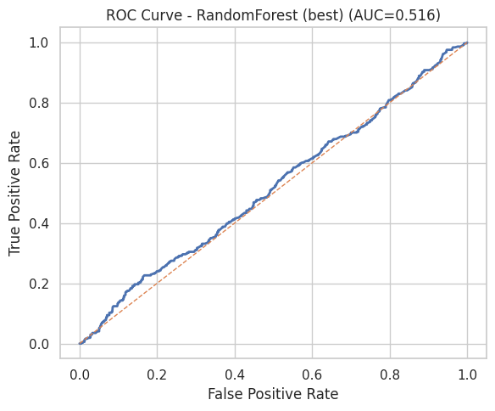
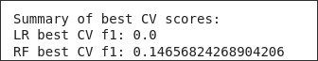
LEARNING OUTCOME:
Data Preprocessing & Encoding:
Gained hands-on experience in cleaning and transforming categorical and numerical data using one-hot encoding and standardization for machine learning readiness.
Model Optimization & Cross-Validation:
Learned to apply GridSearchCV and RandomizedSearchCV with StratifiedKFold to tune hyperparameters systematically and avoid overfitting.
Model Evaluation & Metrics:
Understood how to evaluate classification models using F1-score, ROC-AUC, and visualization of ROC curves for performance comparison.
Comparative Model Insight:
Developed the ability to compare linear (Logistic Regression) and ensemble (Random Forest) classifiers to select the best-performing model for binary classification tasks.

INPUT :
import tensorflow as tf
from tensorflow import keras
from tensorflow.keras import layers
from sklearn.model_selection import train_test_split
import numpy as np
import matplotlib.pyplot as plt
import pandas as pd

(X_train_full, y_train_full), (X_test, y_test) = keras.datasets.mnist.load_data()

X_train_full = X_train_full / 255.0
X_test = X_test / 255.0

X_train, X_val, y_train, y_val = train_test_split(
X_train_full, y_train_full, test_size=5000, random_state=42, stratify=y_train_full
)

y_train_cat = keras.utils.to_categorical(y_train, 10)
y_val_cat = keras.utils.to_categorical(y_val, 10)
y_test_cat = keras.utils.to_categorical(y_test, 10)

keras.backend.clear_session()
np.random.seed(42)
tf.random.set_seed(42)

model = keras.Sequential([
layers.Flatten(input_shape=[28, 28]),
layers.Dense(128, activation="relu"),
layers.Dense(64, activation="relu"),
layers.Dense(10, activation="softmax")
])

model.summary()

model.compile(
loss="categorical_crossentropy",
optimizer="adam",
metrics=["accuracy"]
)

print("Starting model training...")
start_time = tf.timestamp()

history = model.fit(
X_train, y_train_cat,
epochs=10,
batch_size=32,
validation_data=(X_val, y_val_cat)
)

end_time = tf.timestamp()
print(f"\nTraining completed in {end_time - start_time:.2f} seconds.")

pd.DataFrame(history.history).plot(figsize=(10, 6))
plt.gca().set_ylim(0, 1)
plt.title("Model Training History")
plt.xlabel("Epoch")
plt.ylabel("Metric")
plt.grid(True)
plt.show()

print("\nEvaluating on Test Set:")
test_loss, test_acc = model.evaluate(X_test, y_test_cat)
print(f"\nTest Accuracy: {test_acc*100:.2f}%")
print(f"Test Loss: {test_loss:.4f}")

y_proba = model.predict(X_test[:5])
y_pred = np.argmax(y_proba, axis=1)

print(f"\nPredicted classes: {y_pred}")
print(f"Actual classes: {y_test[:5]}")

plt.figure(figsize=(12, 5))
for i in range(5):
plt.subplot(1, 5, i + 1)
plt.imshow(X_test[i], cmap="binary")
plt.title(f"Pred: {y_pred[i]}\nActual: {y_test[i]}")
plt.axis('off')
plt.show()

OUTPUT :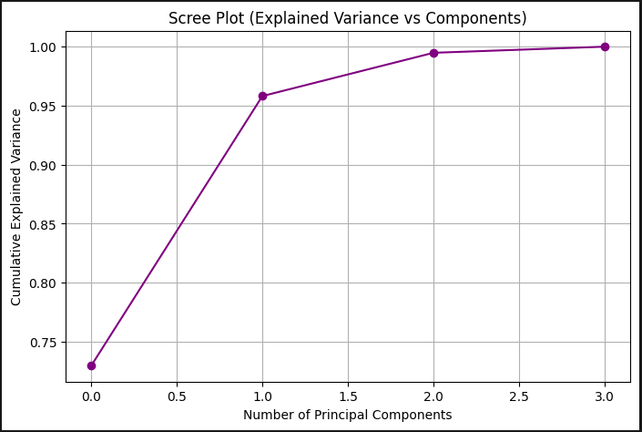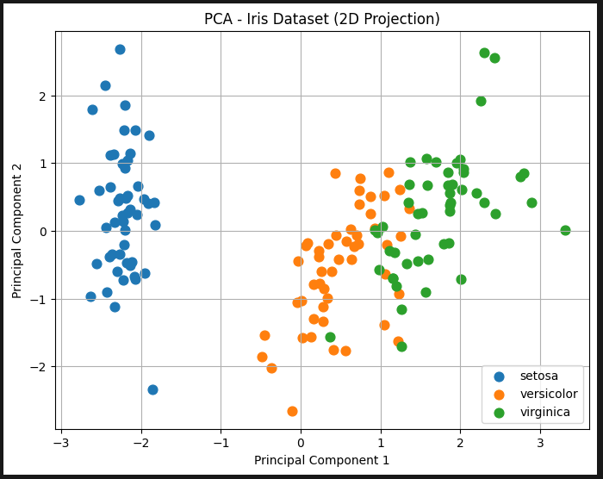
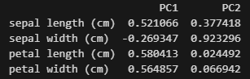

LEARNING OUTCOMES:
- Apply standardization as a prerequisite for distance-based and variance-based methods like PCA.
- Perform Principal Component Analysis (PCA) to reduce the dimensionality of a dataset.
- Interpret the Scree Plot to determine the appropriate number of principal components to retain.
- Visualize high-dimensional data (Iris) in a 2D space defined by the top two principal components.
- Understand and interpret the feature loading scores to determine which original features contribute most significantly to each principal component.

INPUT:
import pandas as pd
import numpy as np
import matplotlib.pyplot as plt
import seaborn as sns
from sklearn.model_selection import train_test_split, GridSearchCV
from sklearn.preprocessing import StandardScaler, OneHotEncoder
from sklearn.impute import SimpleImputer
from sklearn.compose import ColumnTransformer
from sklearn.pipeline import Pipeline
from sklearn.linear_model import LogisticRegression
from sklearn.ensemble import AdaBoostClassifier
from xgboost import XGBClassifier
from sklearn.metrics import classification_report, f1_score

try:
url = 'https://archive.ics.uci.edu/ml/machine-learning-databases/adult/adult.data'
column_names = [
'age', 'workclass', 'fnlwgt', 'education', 'education-num',
'marital-status', 'occupation', 'relationship', 'race', 'sex',
'capital-gain', 'capital-loss', 'hours-per-week', 'native-country', 'income'
]
data = pd.read_csv(url, header=None, names=column_names, na_values=' ?', skipinitialspace=True)
print(f"Dataset loaded with {data.shape[0]} rows.")
except Exception as e:
print(f"Error loading data: {e}. Please check your internet connection.")
exit()

data.dropna(inplace=True)
data = data.drop(['fnlwgt', 'education'], axis=1)
data['income'] = data['income'].map({'<=50K': 0, '>50K': 1})

X = data.drop('income', axis=1)
y = data['income']

numerical_features = X.select_dtypes(include=np.number).columns
categorical_features = X.select_dtypes(include='object').columns

numeric_transformer = Pipeline(steps=[
('imputer', SimpleImputer(strategy='median')),
('scaler', StandardScaler())
])
categorical_transformer = Pipeline(steps=[
('imputer', SimpleImputer(strategy='most_frequent')),
('onehot', OneHotEncoder(handle_unknown='ignore'))
])

preprocessor = ColumnTransformer(
transformers=[
('num', numeric_transformer, numerical_features),
('cat', categorical_transformer, categorical_features)
])
X_train, X_test, y_train, y_test = train_test_split(X, y, test_size=0.2, random_state=42, stratify=y)
print(f"Train set: {X_train.shape[0]} samples | Test set: {X_test.shape[0]} samples")
models = {
"Logistic Regression": LogisticRegression(max_iter=1000, random_state=42),
"AdaBoost": AdaBoostClassifier(random_state=42),
"XGBoost": XGBClassifier(eval_metric='logloss', use_label_encoder=False, random_state=42)
}

params = {
"Logistic Regression": {
'classifier__C': [0.1, 1.0]
},
"AdaBoost": {
'classifier__n_estimators': [50, 100],
'classifier__learning_rate': [0.1, 1.0]
},
"XGBoost": {
'classifier__n_estimators': [100, 200],
'classifier__max_depth': [3, 5],
'classifier__learning_rate': [0.1]
}
}

results = {}
for name, model in models.items():
print(f"--- Training {name} ---")

pipeline = Pipeline(steps=[('preprocessor', preprocessor),
('classifier', model)])

grid_search = GridSearchCV(
pipeline,
param_grid=params[name],
cv=3,
scoring='f1',
n_jobs=-1,
verbose=0
)
grid_search.fit(X_train, y_train)

best_model = grid_search.best_estimator_
y_pred = best_model.predict(X_test)

results[name] = {
"Best Params": grid_search.best_params_,
"Test F1-Score": f1_score(y_test, y_pred),
"Classification Report": classification_report(y_test, y_pred)
}
print(f"Best F1-Score on Test Set for {name}: {results[name]['Test F1-Score']:.4f}\n")

print("\n--- Final Model Comparison ---")
for name, result in results.items():
print(f"Model: {name}")
print(f"Best F1-Score: {result['Test F1-Score']:.4f}")
print(result['Classification Report'])
print("-" * 30)
best_xgb_pipeline = GridSearchCV(
Pipeline([('preprocessor', preprocessor), ('classifier', models['XGBoost'])]),
params['XGBoost'], cv=3, scoring='f1'
).fit(X_train, y_train).best_estimator_
ohe_feature_names = best_xgb_pipeline.named_steps['preprocessor'] \
.named_transformers_['cat']['onehot'] \
.get_feature_names_out(categorical_features)
all_feature_names = list(numerical_features) + list(ohe_feature_names)
importances = best_xgb_pipeline.named_steps['classifier'].feature_importances_
feature_importance = pd.Series(importances, index=all_feature_names).sort_values(ascending=False)
plt.figure(figsize=(10, 8))
feature_importance.head(15).sort_values().plot(kind='barh', title='XGBoost Feature Importance')
plt.xlabel('Importance')
plt.show()

OUTPUT:
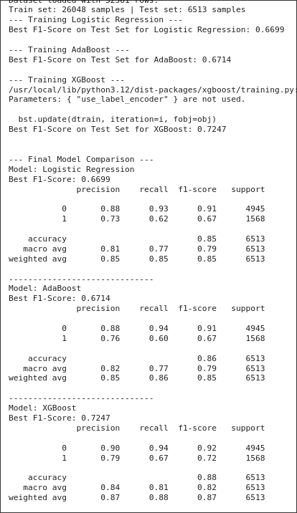
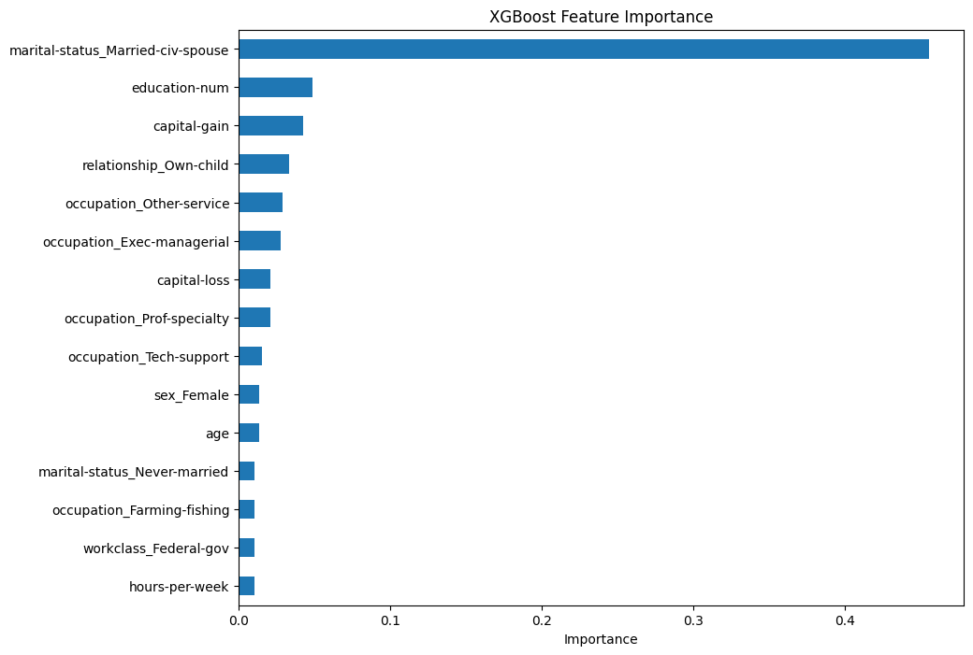

LEARNING OUTCOMES:
Implement a complete data preprocessing pipeline for a complex real-world dataset (Adult Income).
Train, tune, and evaluate advanced ensemble classifiers: AdaBoost and XGBoost.
Apply systematic hyperparameter tuning techniques (Grid Search and Randomized Search).
Utilize early stopping in gradient boosting to optimize the number of weak learners.
Perform feature importance analysis on tree-based models to understand which features drive predictions.
Rigorously compare model performance using a comprehensive set of test set metrics (Accuracy, F1-Score, ROC AUC).

INPUT :
import tensorflow as tf
from tensorflow import keras
from tensorflow.keras import layers
from sklearn.model_selection import train_test_split
import numpy as np
import matplotlib.pyplot as plt
import pandas as pd

(X_train_full, y_train_full), (X_test, y_test) = keras.datasets.mnist.load_data()

X_train_full = X_train_full / 255.0
X_test = X_test / 255.0

X_train, X_val, y_train, y_val = train_test_split(
X_train_full, y_train_full, test_size=5000, random_state=42, stratify=y_train_full
)

y_train_cat = keras.utils.to_categorical(y_train, 10)
y_val_cat = keras.utils.to_categorical(y_val, 10)
y_test_cat = keras.utils.to_categorical(y_test, 10)

keras.backend.clear_session()
np.random.seed(42)
tf.random.set_seed(42)

model = keras.Sequential([
layers.Flatten(input_shape=[28, 28]),
layers.Dense(128, activation="relu"),
layers.Dense(64, activation="relu"),
layers.Dense(10, activation="softmax")
])

model.summary()

model.compile(
loss="categorical_crossentropy",
optimizer="adam",
metrics=["accuracy"]
)

print("Starting model training...")
start_time = tf.timestamp()

history = model.fit(
X_train, y_train_cat,
epochs=10,
batch_size=32,
validation_data=(X_val, y_val_cat)
)

end_time = tf.timestamp()
print(f"\nTraining completed in {end_time - start_time:.2f} seconds.")

pd.DataFrame(history.history).plot(figsize=(10, 6))
plt.gca().set_ylim(0, 1)
plt.title("Model Training History")
plt.xlabel("Epoch")
plt.ylabel("Metric")
plt.grid(True)
plt.show()

print("\nEvaluating on Test Set:")
test_loss, test_acc = model.evaluate(X_test, y_test_cat)
print(f"\nTest Accuracy: {test_acc*100:.2f}%")
print(f"Test Loss: {test_loss:.4f}")

y_proba = model.predict(X_test[:5])
y_pred = np.argmax(y_proba, axis=1)

print(f"\nPredicted classes: {y_pred}")
print(f"Actual classes: {y_test[:5]}")

plt.figure(figsize=(12, 5))
for i in range(5):
plt.subplot(1, 5, i + 1)
plt.imshow(X_test[i], cmap="binary")
plt.title(f"Pred: {y_pred[i]}\nActual: {y_test[i]}")
plt.axis('off')
plt.show()
OUTPUT :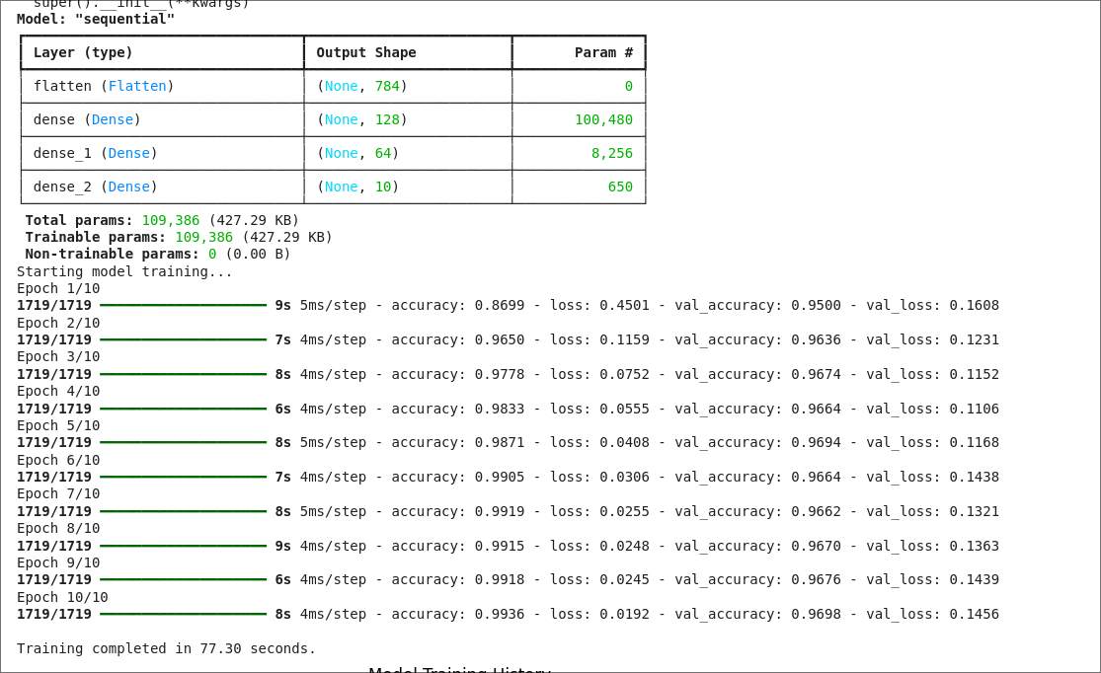
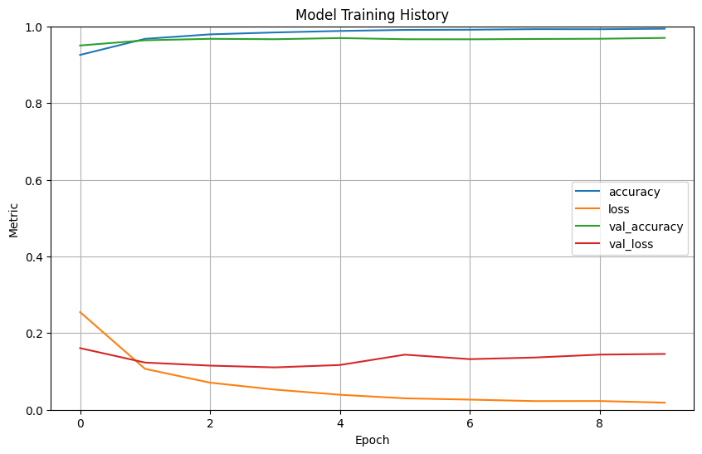
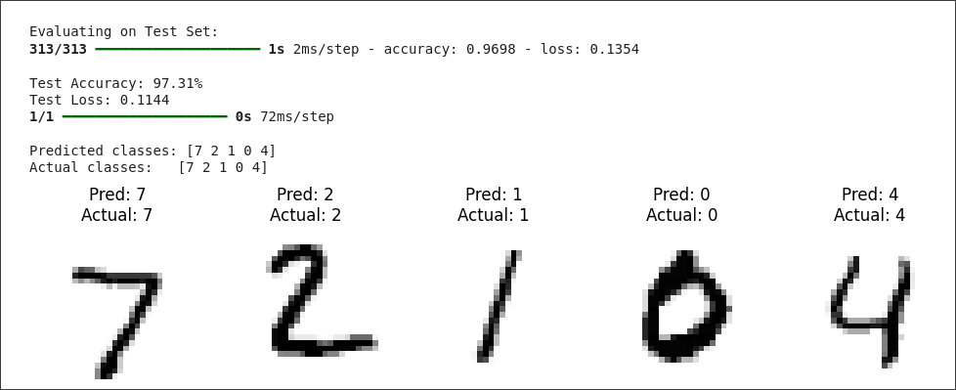

LEARNING OUTCOMES:
Understand the fundamental structure and components of an Artificial Neural Network (ANN), including input, hidden, and output layers.
Apply the concepts of forward propagation, loss calculation, and backpropagation for training a deep learning model.
Implement and train an ANN using a popular deep learning library (TensorFlow/Keras) for a multi-class classification task.
Utilize key neural network components such as Flatten layers, Dense layers, and activation functions (ReLU, Softmax).
Evaluate the performance of the ANN using loss and accuracy metrics and interpret the training history (loss and accuracy curves).

INPUT:
import numpy as np
import matplotlib.pyplot as plt
from sklearn.datasets import make_blobs
from sklearn.cluster import KMeans

X, y_true = make_blobs(n_samples=300, centers=4, cluster_std=0.70, random_state=0)

plt.figure(figsize=(8, 6))
plt.scatter(X[:, 0], X[:, 1], s=50)
plt.title('Raw Unclustered Data')
plt.xlabel('Feature 1')
plt.ylabel('Feature 2')
plt.grid(True)
plt.show()

wcss = []
for i in range(1, 11):
kmeans = KMeans(n_clusters=i, init='k-means++', max_iter=300, n_init=10, random_state=0)
kmeans.fit(X)
wcss.append(kmeans.inertia_) # inertia_ is the WCSS value

plt.figure(figsize=(8, 6))
plt.plot(range(1, 11), wcss, marker='o', linestyle='--')
plt.title('The Elbow Method')
plt.xlabel('Number of clusters (K)')
plt.ylabel('WCSS (Inertia)')
plt.grid(True)
plt.show()

optimal_k = 4
kmeans = KMeans(n_clusters=optimal_k, init='k-means++', max_iter=300, n_init=10, random_state=0)

y_kmeans = kmeans.fit_predict(X)

plt.figure(figsize=(10, 7))

plt.scatter(X[y_kmeans == 0, 0], X[y_kmeans == 0, 1], s=50, c='red', label='Cluster 1')
plt.scatter(X[y_kmeans == 1, 0], X[y_kmeans == 1, 1], s=50, c='blue', label='Cluster 2')
plt.scatter(X[y_kmeans == 2, 0], X[y_kmeans == 2, 1], s=50, c='green', label='Cluster 3')
plt.scatter(X[y_kmeans == 3, 0], X[y_kmeans == 3, 1], s=50, c='cyan', label='Cluster 4')

centers = kmeans.cluster_centers_
plt.scatter(centers[:, 0], centers[:, 1], s=200, c='yellow', marker='*', label='Centroids', edgecolors='black')

plt.title('K-Means Clustering Results')
plt.xlabel('Feature 1')
plt.ylabel('Feature 2')
plt.legend()
plt.grid(True)
plt.show()

OUTPUT:
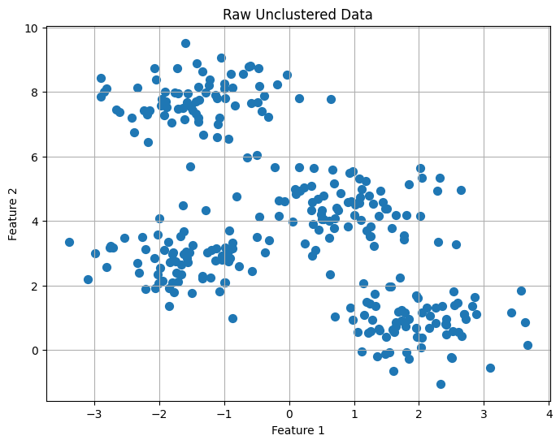
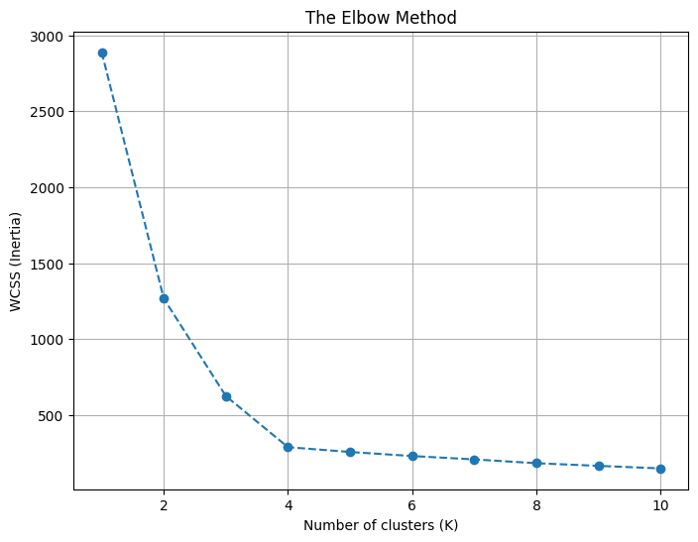
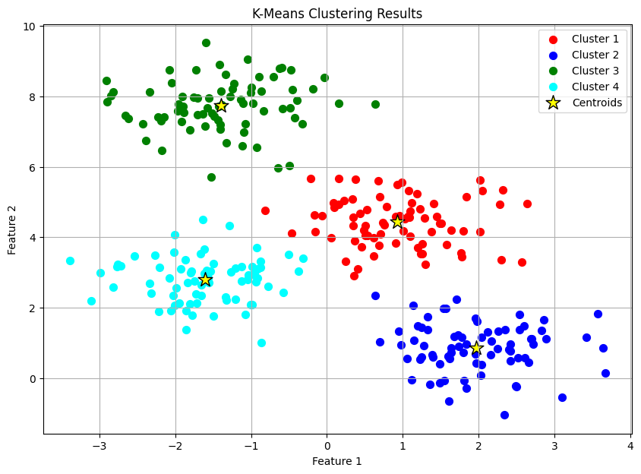

LEARNING OUTCOMES :
After studying this topic, you will be able to:
Explain the goal and step-by-step process of the K-Means algorithm.
Define key terms like centroid, cluster, and WCSS (inertia).
Use the Elbow Method to determine an optimal number of clusters (K).
Interpret the groups formed by the algorithm on a given dataset.
Identify the main limitations of K-Means, such as its sensitivity to initial centroids and its assumption of spherical clusters.

